Executive Summary

**Airbnb Data Analysis Software**

**Student Names:**

Sarah Mitchell s5316578

Lina Kim s5188279

Sonya Jung s5276105

# Abstract

In this Airbnb data analysis software, we present a comprehensive analysis of Airbnb data focusing on enhancing the user experience and providing valuable insights. Analysis 1 allows users to explore Airbnb listings in a chosen suburb, specifying check-in and check-out dates for informed decision-making. Analysis 2 refines data presentation by generating price distribution charts for user-defined periods, making data more accessible and contextually relevant. Analysis 3 empowers users to retrieve listings containing specific keywords, optimising search precision. Analysis 4 delves into customer comments related to cleanliness, aiding users in finding accommodations that align with their preferences through the carefully selected keyword options. Finally, Analysis 5 offers users flexibility in defining their price range, streamlining their search for the perfect Airbnb listing. Collectively, these analyses contribute to an improved Airbnb experience by enhancing search precision, data visualisation, and filtering options, facilitating well-informed accommodation choices for users.

# Introduction

This report aims to provide a detailed overview of the Airbnb data analysis software and its capabilities. We aim to enhance the user experience by offering valuable insights and tools for informed decision-making when using Airbnb. The analysis covers a specific date range, primarily focusing on the period from December 7, 2018, to December 6, 2019. This report presents five distinct analysis tasks that empower users to interact with Airbnb data more effectively and intuitively.

Analysis 1:

* Explore Airbnb Listings in a Chosen Suburb (Date Range: December 7, 2018, to December 6, 2019)
* Users can select a specific suburb, specify check-in and check-out dates, and retrieve information for all Airbnb listings in that area during the chosen period. This analysis facilitates location-based decision-making.

Analysis 2:

* Price Distribution Visualization (Date Range: December 7, 2018, to December 6, 2019)
* Users can generate a price distribution chart by selecting a date range. This chart visualises the distribution of property prices, offering insights into pricing trends within the specified period.

Analysis 3:

* Keyword-Based Property Retrieval (Date Range: December 7, 2018, to December 6, 2019)
* Users can enter specific keywords (e.g., "pool" or "pet") and retrieve Airbnb listings that match their criteria. This analysis aids users in finding accommodations that align with their preferences.

Analysis 4:

* Cleanliness-Related Customer Comments Analysis (Date Range: N/A)
* Users can analyse customer comments related to cleanliness using a selection of positive cleanliness keywords. This analysis helps users identify properties with a high level of cleanliness as reflected in customer feedback.

Analysis 5:

* Customisable Price Range Search (Date Range: N/A)
* Users have the flexibility to define their own price range when searching for Airbnb listings. This feature streamlines the search process by allowing users to specify their budget preferences.

These analysis tasks collectively contribute to an improved Airbnb experience by enhancing search precision, providing data visualisation, and offering filtering options. The software's capabilities empower users to make well-informed accommodation choices, ultimately enhancing their overall satisfaction when using Airbnb.

Analysis 1 - For a user-selected period, report the information of all listings in a specified suburb.

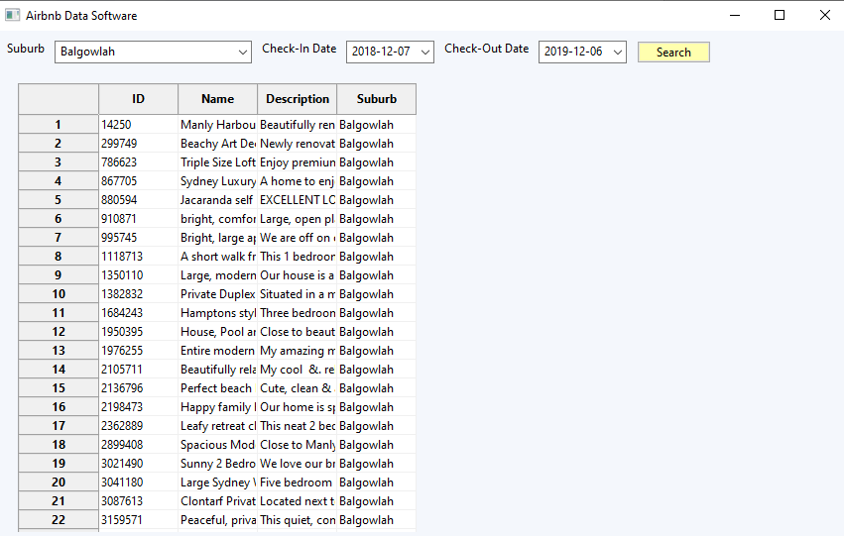After the user selects a suburb, specifies check-in and check-out dates, and presses the search button, the data chart will display relevant information for all Airbnb listings. For example, if the user has chosen "Balgowlah" as the suburb and set "2018-12-07" as the check-in date and "2019-12-06" as the check-out date, the screen will appear as shown below once the search results have loaded.

Analysis 2 - For a user-selected period, produce a chart to show the distribution of prices of properties.

When the user selects a check-in and check-out date range and then presses the "Plot" button, a bar graph displaying the corresponding price distribution for the chosen period will be generated. In this particular case, the user has selected a 12-month period spanning from 07/12/2018 to 06/12/2019.

Originally, the price distribution over this 12-month period ranged from a minimum of $0 to a maximum of $14,999. However, this presentation was found to be ineffective for analysis due to the scarcity of properties priced above $2000. To enhance the graph's utility, the price range has been adjusted to $0-$1000, with divisions at every $100 interval.

With this updated price range, the graph provides clearer insights. Furthermore, the graph's title dynamically changes to reflect the selected period, ensuring that it remains contextually relevant.

# **Analysis 3 - For a user-selected period, retrieve all records that contain a keyword (user entered), e.g. pool, pet.**

After the user specifies check-in and check-out dates, enters a keyword, and presses the search button, the data chart will display relevant information for all Airbnb listings. For example, if the user has entered "Bright" as the keyword and set "2018-12-07" as the check-in date and "2019-12-06" as the check-out date, the screen will appear as shown below once the search results have loaded.

# 

# **Analysis 4 - Analysing how many customers commented on factors related to cleanliness (multiple key words may be associated with cleanliness – justify your selection).**

After the user selects a cleanliness keyword and presses the search button, the data chart will display relevant information for all Airbnb listings. For example, if the user has selected "Tidy" as the keyword the screen will appear as shown below once the search results have loaded.

The list of cleanliness keywords includes: "aseptic," "crisp," "disinfected," "elegant," "fresh," "gleaming," "hygienic," "immaculate," "neat," "pristine," "sanitary," "shining," "spotless," "sterile," "tidy," "unblemished," and "well-kept." These keywords are consistently used in a positive context in the Airbnb comments, ensuring that users are only presented with results for properties that have received positive feedback.

Notably, we do not include the word "Clean" in the list because it can be used in both positive and negative contexts, especially when paired with words like "not." This criteria helps maintain a strict focus on positive cleanliness keywords for a more accurate search experience.

# **Analysis 5 - For a user-selected price, retrieve all records that fall under the price range.**

Users have the flexibility to define their own price range, entering any prices in the minimum and maximum text boxes. After the user presses the "Search" button, Airbnb listings falling within the user-specified price range will be displayed in the database table. For instance, if the user selects a price range of $200 to $500, the results will be presented as follows.

After the user establishes their desired price range and activates the search by clicking the "Search" button, the results will be presented, including the Airbnb ID, name, and corresponding price. Only listings that fall within the user-selected price range will be displayed.

